GameTime - Detailed Design
Submitted by: Amit Donel, Ofek Weiss, Shoam Tomer
Part 1: Architecture
MVC Architecture
The GameTime project follows the Model-View-Controller (MVC) architecture to ensure modularity, scalability, and ease of maintenance.
- Model:
  - Manages user profiles, game details, and location data.
  - Handles data retrieval, storage, and processing using PostgreSQL.
- View:
  - Implements the user interface using Flutter for both mobile and web platforms. (Web - Optional)
  - Displays game details, player profiles, and maps.
- Controller:
  - Acts as a bridge between the Model and View.
  - Processes user inputs and updates the Model and View accordingly.
Part 2: Data Description
Database Tables
- User Table:
  - Fields: user_id, name, email, password_hash, skill_level, preferred_position, location.
- Game Table:
  - Fields: game_id, organizer_id, location, time, skill_level, max_players, current_players.
- Location Table:
  - Fields: location_id, latitude, longitude, surface_type, rain_cover, shade_cover.
- Player Feedback Table:
  - Fields: feedback_id, game_id, player_id, rating, comments.
- Weather Data Table:
  - Fields: weather_id, game_id, temperature, condition.
- Team Allocation Table:
  - Fields: allocation_id, game_id, team, player_id.

Part 3: Graphic Description
Data Flow Diagram
- User Interaction: Players register and create profiles through the View layer.
- Game Creation: Organizers input game details, stored in the database via the Model layer.
- Matchmaking: The Controller processes player data to allocate teams.
- Real-Time Updates: Weather and location data are fetched through APIs.
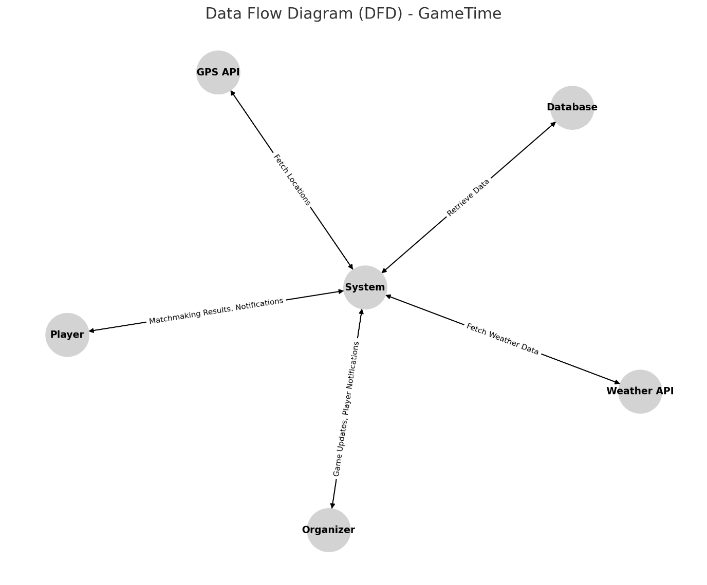

Part 4: API Specification
Key APIs
- User Management API:
  - POST /register: Register a new user.
  - POST /login: User login.
  - GET /profile: Retrieve user profile.
- Game Management API:
  - POST /create_game: Create a new game.
  - GET /games: Fetch available games based on preferences.
  - POST /join_game: Join a game.
- Weather Integration API:
  - GET /weather: Fetch weather conditions for a location.
- Location Services API:
  - GET /nearby_fields: Retrieve nearby football fields based on GPS coordinates.
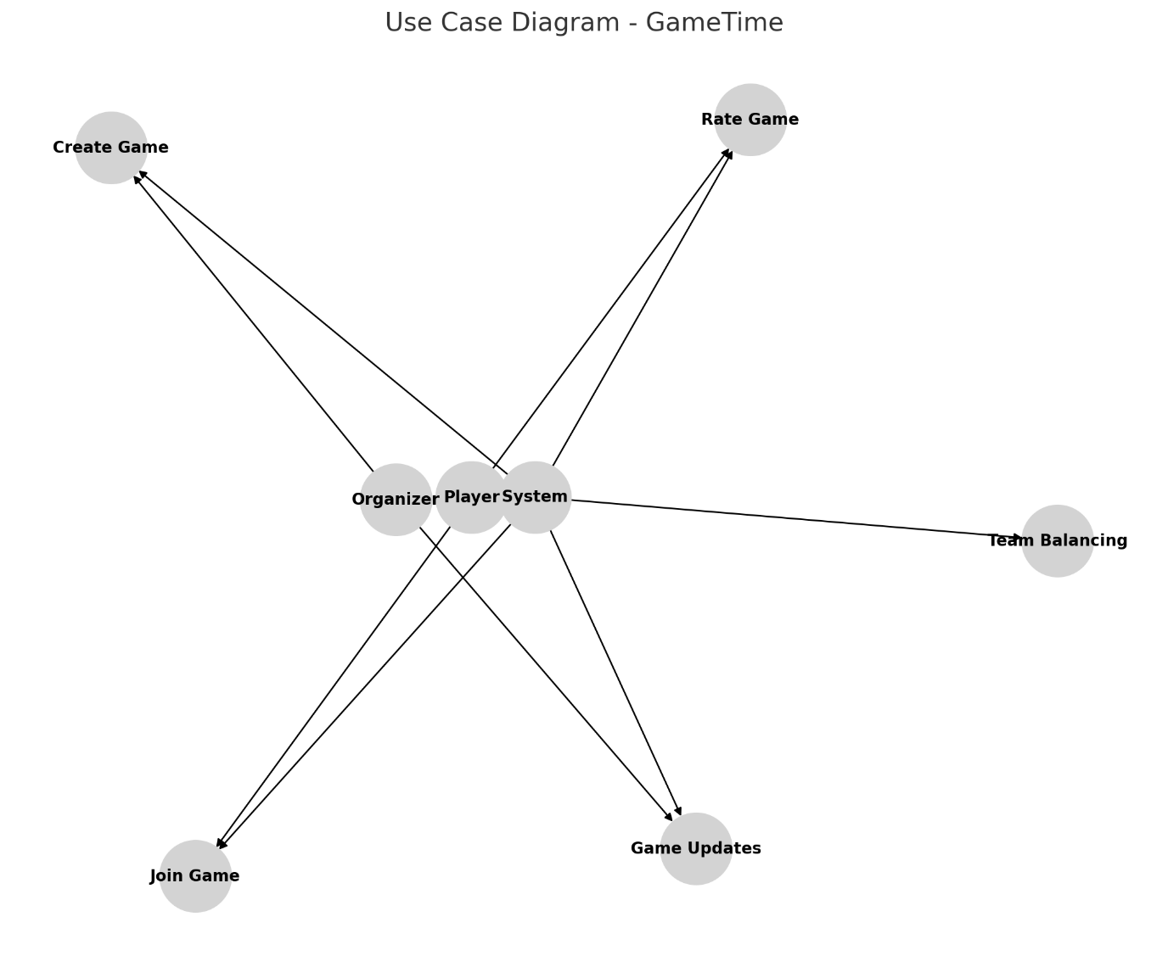

Part 5: Interface Design
Key Screens
- Login and Registration:
  - Input fields for email/password or social login buttons.
- Home Screen:
  - List of available games with search and filter options.
- Game Details:
  - Display game information, join button, and chat option.
- Profile Screen:
  - Editable user profile with preferences and statistics.
- Organizer Dashboard:
  - Tools for game management and player notifications.
Part 6: Programming Languages and Tools
- Frontend: Flutter
- Backend: Node.js with Express
- Database: PostgreSQL and Redis for caching
- APIs: Google Maps API, OpenWeatherMap API
- Testing: Postman for API testing
- Version Control: GitHub
Part 7: Algorithms Description
- Team Balancing Algorithm:
  - Matches players based on skill levels and positions.
  - Uses a weighted scoring system to create balanced teams.
- Matchmaking Algorithm:
  - Filters games based on player preferences and location proximity.
- Weather Handling Algorithm:
  - Analyzes weather data to suggest rescheduling or alternative locations.
- Real-Time Notifications:
  - Implements WebSockets to notify players of game updates.

Part 8: Non-Functional Requirements
- Performance:
  - Response time: <500ms for API calls.
  - Concurrent users: Support for up to 100 users.
- Scalability:
  - Modular architecture to support horizontal scaling.
- Security:
  - Passwords stored as hashed values.
  - Secure communication with HTTPS.
- Usability:
  - Intuitive UI for smooth user navigation.
  - Accessibility features for inclusivity.
- Reliability:
  - 99% uptime with basic redundancy mechanisms.
Part 9: Testing Plan
- Unit Tests:
  - Test individual components like user registration and matchmaking.
- Integration Tests:
  - Validate the interaction between APIs and the database.
- System Tests:
  - End-to-end testing of core functionalities like game creation and team allocation.
- User Testing:
  - Gather feedback from target users to refine features.
By following this detailed design, the GameTime project aims to deliver a robust and user-friendly platform for organizing and managing amateur football games.

